Asymmetric DCC correlation: NZDUSD and EURGBP
Method 10 / GARCH(1,1) + Cappiello-Engle-Sheppard ADCC / Alpari D1 full available history

Study setup
Logical pair: NZDUSD , EURGBP
Broker symbols: NZDUSD_i , EURGBP_i
Snapshot: 2026-11-03_majors_alpari_D1
Timeframe: D1
Matched return window: 1999-01-06 to 2026-11-02 (UTC bar dates)
Matched return count n: 7183
Dropped unfinished last bar dated 2026-11-03 UTC after a tick-volume check against the prior complete day.
NZDUSD GARCH(1,1): mu=0.000000, omega=0.004923, alpha=0.040784, beta=0.950246
EURGBP GARCH(1,1): mu=-0.000019, omega=0.000668, alpha=0.046768, beta=0.951531
ADCC: a=0.009356, b=0.988547, g=0.000005, a+b+g/2=0.997906
Nested DCC (g=0): a=0.009358, b=0.988547
Negative shock: n = min(z, 0) in broker quote direction (not inverted)
Burn-in ignored in path summaries and chart: first 60 updates
Complete matched rows (Excel): NZDUSD-EURGBP_ADCC_D1.xlsx
Complete matched rows (HTML table): NZDUSD-EURGBP_ADCC_D1_data.html

Method carried forward
Asymmetric DCC extends Engle DCC with an extra term on joint negative standardised shocks. Each matched daily log return of close, ln(close_t / close_t-1), is first filtered by a constant-mean GARCH(1,1). Then z = residual / sigma and n = min(z, 0). The Cappiello-Engle-Sheppard recursion uses A = (1-a-b) Q_bar - g N_bar with N_bar = mean(n n'). Quotes are not inverted, so a negative shock is a negative log return in the broker quote. Nested symmetric DCC (g = 0) is fit on the same z path for comparison. Constraints: a,b,g >= 0 and a + b + g/2 < 1. Path summaries ignore the first 60 updates. The headline is latest ADCC rho. Pearson r is a side check only. This is not a cause, lead, or trading signal.

Results
Latest ADCC rho: -0.114065
Latest nested DCC rho: -0.114054
Post-burn-in ADCC path (n=7123): mean=0.033446, median=0.038720, min=-0.299880, max=0.413282, std=0.147222
Share of post-burn-in days with |rho| >= 0.4: 0.06%; |rho| >= 0.7: 0.00%
Same-sample Pearson r: 0.037186
ADCC minus r: -0.151252
ADCC minus nested DCC: -0.000011

Conclusion
Over 7183 matched daily log-return rows for NZDUSD and EURGBP (broker quote directions unchanged), latest ADCC rho is -0.1141 (negative, weak conditional linear link in this sample) with fitted a=0.0094, b=0.9885, g=0.0000. Nested symmetric DCC latest rho is -0.1141 (ADCC minus DCC = -0.0000). After a 60-day burn-in, path mean is 0.0334 and std is 0.1472. Same-sample Pearson r is 0.0372 (ADCC minus r = -0.1513). This does not establish cause, lead-lag, or a lasting trading rule.

Charts
Daily closes

Daily log returns
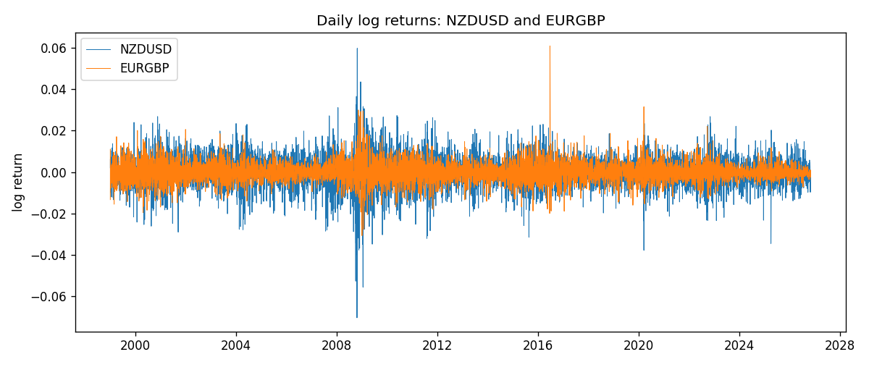
ADCC rho path with nested DCC and Pearson r
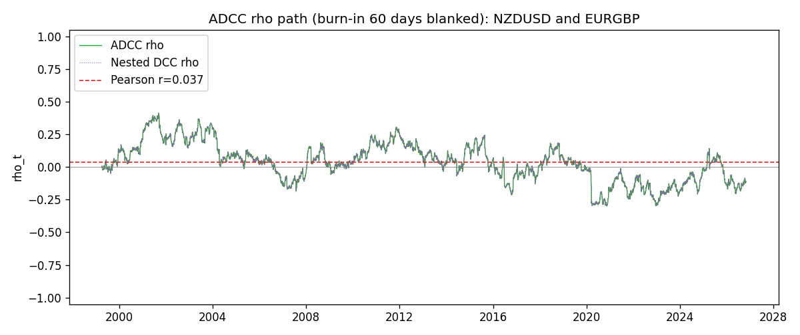

Data report
Every matched row that entered the ADCC recursion is stored in the sibling Excel workbook named NZDUSD-EURGBP_ADCC_D1.xlsx. Embedding all rows as a Word table is impractical at this length; the Word file holds the column list, column summaries, and the first and last 15 matched rows.
Columns: time, NZDUSD_open, EURGBP_open, NZDUSD_high, EURGBP_high, NZDUSD_low, EURGBP_low, NZDUSD_close, EURGBP_close, NZDUSD_tick_volume, EURGBP_tick_volume, NZDUSD_spread, EURGBP_spread, NZDUSD_real_volume, EURGBP_real_volume, NZDUSD_log_return, EURGBP_log_return, NZDUSD_sigma, EURGBP_sigma, NZDUSD_z, EURGBP_z, NZDUSD_n, EURGBP_n, q11, q22, q12, rho_adcc, rho_dcc
Column summaries (matched calculation rows)
column | count | mean | std | min | 25% | 50% | 75% | max
NZDUSD_open | 7183 | 0.65646991 | 0.10818219 | 0.3913 | 0.591455 | 0.6684 | 0.72495 | 0.88218
EURGBP_open | 7183 | 0.78694248 | 0.0966971 | 0.5734 | 0.68755 | 0.83389 | 0.86522 | 0.9769
NZDUSD_high | 7183 | 0.66038812 | 0.10867344 | 0.3961 | 0.5949 | 0.67204 | 0.729365 | 0.88421
EURGBP_high | 7183 | 0.7900202 | 0.09707133 | 0.5789 | 0.6896 | 0.8369 | 0.8681 | 0.9799
NZDUSD_low | 7183 | 0.65278196 | 0.10777661 | 0.3897 | 0.58816 | 0.6642 | 0.720985 | 0.87988
EURGBP_low | 7183 | 0.78424251 | 0.0965143 | 0.5682 | 0.6855 | 0.83166 | 0.86287 | 0.9661
NZDUSD_close | 7183 | 0.65654354 | 0.10817679 | 0.3907 | 0.59181 | 0.6685 | 0.72502 | 0.8822
EURGBP_close | 7183 | 0.78698724 | 0.09669475 | 0.5735 | 0.68775 | 0.83395 | 0.86536 | 0.977
NZDUSD_tick_volume | 7183 | 68736.568 | 123152.54 | 16 | 5594.5 | 33901 | 58513.5 | 1127682
EURGBP_tick_volume | 7183 | 87133.158 | 145499.84 | 154 | 6553 | 44358 | 81413 | 1424684
NZDUSD_spread | 7183 | 30.260755 | 25.633067 | 0 | 9 | 17 | 40 | 80
EURGBP_spread | 7183 | 21.328832 | 19.122264 | 0 | 4 | 13 | 40 | 50
NZDUSD_real_volume | 7183 | 1.6708354e+10 | 8.49951e+10 | 0 | 0 | 0 | 0 | 2.705649e+12
EURGBP_real_volume | 7183 | 2.7872287e+10 | 1.3521454e+11 | 0 | 0 | 0 | 0 | 3.5726265e+12
NZDUSD_log_return | 7183 | 1.073e-05 | 0.0076464 | -0.07027433 | -0.00425909 | 0.00022967 | 0.00458236 | 0.05966839
EURGBP_log_return | 7183 | 2.33e-05 | 0.00487088 | -0.03067367 | -0.00262163 | -9.879e-05 | 0.002558 | 0.06075387
NZDUSD_sigma | 7183 | 0.00728928 | 0.00217212 | 0.0043867 | 0.00595705 | 0.00670913 | 0.00804629 | 0.02525596
EURGBP_sigma | 7183 | 0.00463465 | 0.00169386 | 0.001859 | 0.00343265 | 0.00442133 | 0.00552139 | 0.01551095
NZDUSD_z | 7183 | -0.00191018 | 1.0000748 | -5.6204222 | -0.63001315 | 0.03308143 | 0.64713471 | 4.1973773
EURGBP_z | 7183 | 0.00790277 | 1.0000696 | -3.7945968 | -0.62259575 | -0.0197271 | 0.59734441 | 8.4770453
NZDUSD_n | 7183 | -0.38927119 | 0.61564029 | -5.6204222 | -0.63001315 | 0 | 0 | 0
EURGBP_n | 7183 | -0.37932366 | 0.5702251 | -3.7945968 | -0.62259575 | -0.0197271 | 0 | 0
q11 | 7183 | 1.00224 | 0.10825883 | 0.74410822 | 0.92869026 | 0.98564185 | 1.0618094 | 1.63042
q22 | 7183 | 1.0028606 | 0.10471577 | 0.75514687 | 0.93706945 | 0.99693031 | 1.0573258 | 1.8020853
q12 | 7183 | 0.03516106 | 0.14944511 | -0.39352507 | -0.06841548 | 0.03800727 | 0.13551672 | 0.41839487
rho_adcc | 7183 | 0.0333649 | 0.14662544 | -0.2998802 | -0.06979586 | 0.03837988 | 0.13107643 | 0.4132822
rho_dcc | 7183 | 0.03336595 | 0.14662554 | -0.29988049 | -0.06980024 | 0.03837862 | 0.13108052 | 0.41327206
First 15 matched rows (selected columns)
time | NZDUSD_log_return | EURGBP_log_return | NZDUSD_z | EURGBP_z | NZDUSD_n | EURGBP_n | q11 | q22 | q12 | rho_adcc | rho_dcc
1999-01-06 | 0.0020455609 | -0.013303338 | 0.33937399 | -2.3697682 | 0 | -2.3697682 | 1 | 1 | 0.03364493 | 0.03364493 | 0.03364493
1999-01-07 | 0.0062963171 | 0.011051402 | 1.0616172 | 1.7907898 | 0 | 0 | 0.99171863 | 1.0432123 | 0.025804531 | 0.025369703 | 0.025369383
1999-01-08 | -0.00055396548 | -0.004943862 | -0.093013653 | -0.75835924 | -0.093013653 | -0.75835924 | 0.99299947 | 1.0633641 | 0.043366534 | 0.0422026 | 0.042205933
1999-01-11 | 0.010290425 | -0.0012752393 | 1.7578419 | -0.19534993 | 0 | -0.19534993 | 0.98380164 | 1.0586635 | 0.043599912 | 0.042722128 | 0.042725964
1999-01-12 | -0.0053157489 | 0.0033970309 | -0.86961519 | 0.54388162 | -0.86961519 | 0 | 1.0035396 | 1.0489902 | 0.03995735 | 0.038944283 | 0.038948121
1999-01-13 | -0.0099742238 | 0.00042381861 | -1.6363413 | 0.071761841 | -1.6363413 | 0 | 1.0012193 | 1.0418381 | 0.03514416 | 0.034410299 | 0.034414114
1999-01-14 | -0.00018564931 | -0.0019793588 | -0.029477695 | -0.32490617 | -0.029477695 | -0.32490617 | 1.0169122 | 1.0320484 | 0.033712687 | 0.032908008 | 0.032912441
1999-01-15 | -0.00074294208 | -0.0076715819 | -0.12001248 | -1.2958601 | -0.12001248 | -1.2958601 | 1.0073677 | 1.0233109 | 0.033485962 | 0.032981087 | 0.032986203
1999-01-18 | -0.0018597736 | 0.00071280921 | -0.30592056 | 0.12207466 | -0.30592056 | 0 | 0.99805913 | 1.0294052 | 0.034628033 | 0.034163041 | 0.034168423
1999-01-19 | 0.0018597736 | -0.0014261269 | 0.31088355 | -0.24006691 | 0 | -0.24006691 | 0.98959846 | 1.0198491 | 0.03395175 | 0.033795953 | 0.03380199
1999-01-20 | 0.0040793678 | 0.0019960086 | 0.69320469 | 0.3517715 | 0 | 0 | 0.98126288 | 1.0108026 | 0.032934332 | 0.033069148 | 0.033075777
1999-01-21 | 0.0040627941 | -0.00071240297 | 0.6959556 | -0.12347353 | 0 | -0.12347353 | 0.97661454 | 1.002478 | 0.034908425 | 0.035280216 | 0.035287934
1999-01-22 | -0.012051689 | -0.0017118406 | -2.0810037 | -0.30869192 | -2.0810037 | -0.30869192 | 0.9720552 | 0.99323364 | 0.033774331 | 0.034372852 | 0.034381122
1999-01-25 | -0.0035504102 | -0.0054402425 | -0.57384741 | -1.0100959 | -0.57384741 | -1.0100959 | 1.0035559 | 0.98484448 | 0.039470816 | 0.039702832 | 0.039709844
1999-01-26 | 0.0072741158 | -0.00057438255 | 1.1895188 | -0.10331827 | 0 | -0.10331827 | 0.99723888 | 0.9852106 | 0.044514659 | 0.044909572 | 0.044915492
Last 15 matched rows (selected columns)
time | NZDUSD_log_return | EURGBP_log_return | NZDUSD_z | EURGBP_z | NZDUSD_n | EURGBP_n | q11 | q22 | q12 | rho_adcc | rho_dcc
2026-10-13 | 0.0047326165 | 0.00020130374 | 0.96126908 | 0.10936533 | 0 | 0 | 0.82747003 | 0.78009 | -0.069911325 | -0.087015985 | -0.087004749
2026-10-14 | -0.0037306483 | 0.0011241873 | -0.75481252 | 0.57565479 | -0.75481252 | 0 | 0.82873266 | 0.77336177 | -0.0680573 | -0.085011198 | -0.084998668
2026-10-15 | 0.0047634855 | -0.00087557391 | 0.96665661 | -0.43440396 | 0 | -0.43440396 | 0.82666864 | 0.7696992 | -0.07127362 | -0.089351648 | -0.089339038
2026-10-16 | 0.0057501001 | -0.0020380844 | 1.1618845 | -1.0359828 | 0 | -1.0359828 | 0.82803763 | 0.7647446 | -0.074316575 | -0.093390444 | -0.093377624
2026-10-19 | 0.0018917133 | -0.00056950988 | 0.3774193 | -0.27959556 | 0 | -0.27959556 | 0.83327902 | 0.76812728 | -0.084657996 | -0.10581718 | -0.10580591
2026-10-20 | 0.0037199341 | -0.0035906254 | 0.75145959 | -1.8408527 | 0 | -1.8408527 | 0.8271622 | 0.76215595 | -0.084606054 | -0.10655754 | -0.10654538
2026-10-21 | 0.0030923331 | -0.00140647 | 0.62674338 | -0.6732471 | 0 | -0.6732471 | 0.82506616 | 0.78724408 | -0.096510365 | -0.11974982 | -0.11974022
2026-10-22 | -0.0033035227 | -0.0018743924 | -0.67430575 | -0.90561302 | -0.67430575 | -0.90561302 | 0.8213859 | 0.78456511 | -0.099283321 | -0.12367678 | -0.123667
2026-10-23 | 0.0030929853 | 0.00082421033 | 0.63455629 | 0.41071966 | 0 | 0 | 0.81832897 | 0.78535122 | -0.092359994 | -0.11520942 | -0.11520133
2026-10-26 | -0.0028993932 | 0.00013133309 | -0.59880535 | 0.074344378 | -0.59880535 | 0 | 0.81481807 | 0.78002917 | -0.088793992 | -0.11137759 | -0.11136782
2026-10-27 | -0.00026399852 | -0.0019957343 | -0.05499868 | -0.9901503 | -0.05499868 | -0.9901503 | 0.81093655 | 0.77324144 | -0.088123874 | -0.11128653 | -0.11127581
2026-10-28 | -0.0097283914 | 0.00066967224 | -2.0526044 | 0.34286529 | -2.0526044 | 0 | 0.80377115 | 0.77565749 | -0.086535118 | -0.10959511 | -0.10958376
2026-10-29 | 0.00062190714 | -0.0011722209 | 0.12258559 | -0.58123896 | 0 | -0.58123896 | 0.83610024 | 0.76996803 | -0.092059086 | -0.11473638 | -0.11472661
2026-10-30 | 0.00019537668 | -0.0024205543 | 0.039039254 | -1.2202852 | 0 | -1.2202852 | 0.82875894 | 0.76640641 | -0.091601706 | -0.11493701 | -0.11492634
2026-11-02 | -0.0025962955 | 0.00089940465 | -0.5280491 | 0.45827868 | -0.5280491 | 0 | 0.82137537 | 0.7736628 | -0.090928636 | -0.11406541 | -0.11405413

